SCP3C04 – SAP Build

|  |  |
| --- | --- |
| **Product**  SAP oud Platform  **Level**  Undergraduate/Graduate  Beginner  **Focus**  Predictive Analytics  **Author** Ross Hightower | MOTIVATION  This case illustrates the SAP Build application prototyping tool  **PREREQUISITES**  SCP3C01 |
|  | |

## SAP Build

SAP Build is a application prototyping tool that allows you to create UI5 based apps quickly and gather feedback from potential users. You can learn more about Build at [https://www.build.me/splashapp](https://www.build.me/splashapp/)/

## Create an Account

Navigate to <https://www.build.me/splashapp/>. If you see the OK Got It button on the top right, click it. Click Sign Up. Enter your email address and complete the registration process. If you already have an SAP ID, use the same email address.

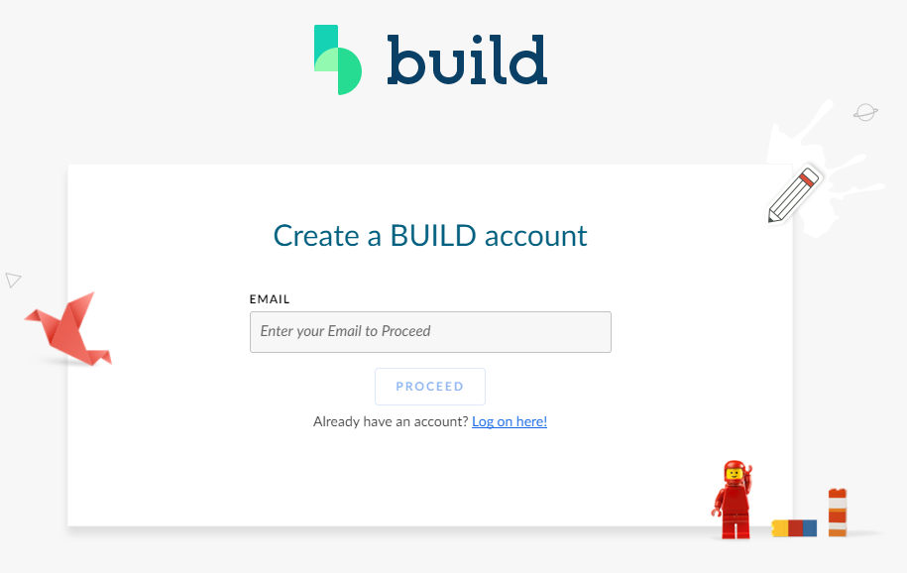

When you get the confirmation email, click Verify Email.

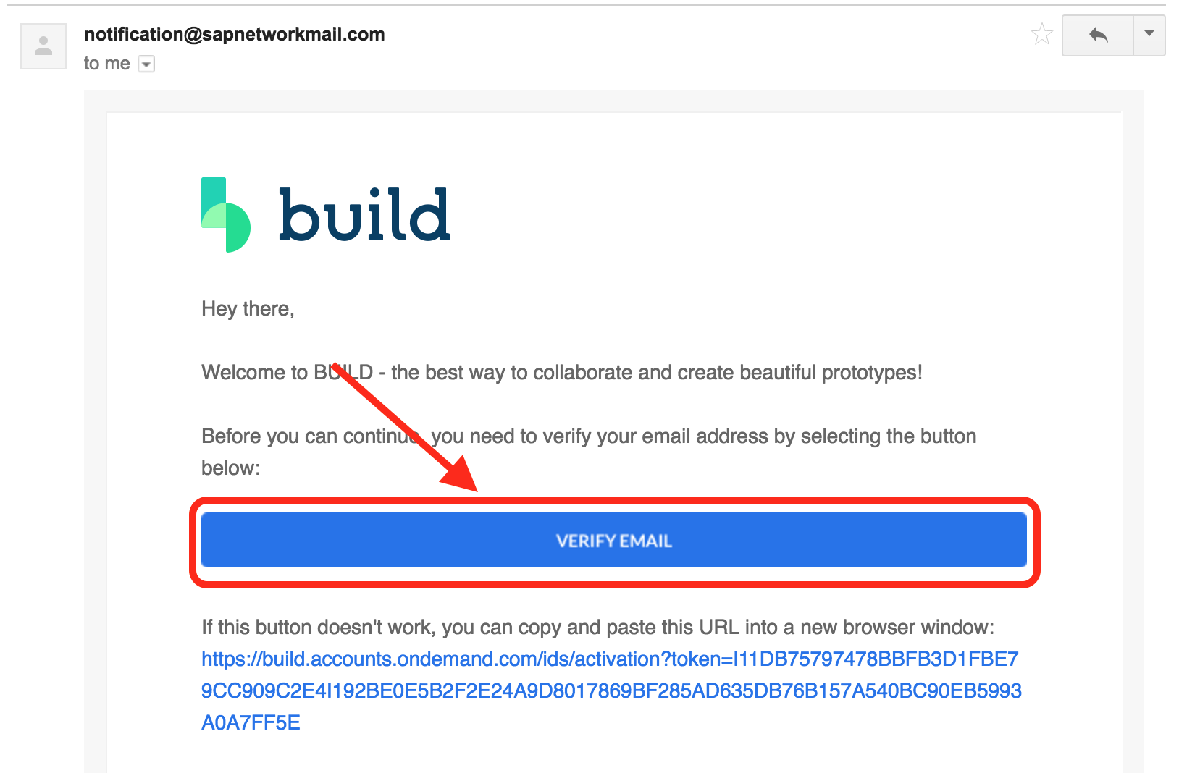

Logon to Build.

## Create a Prototype

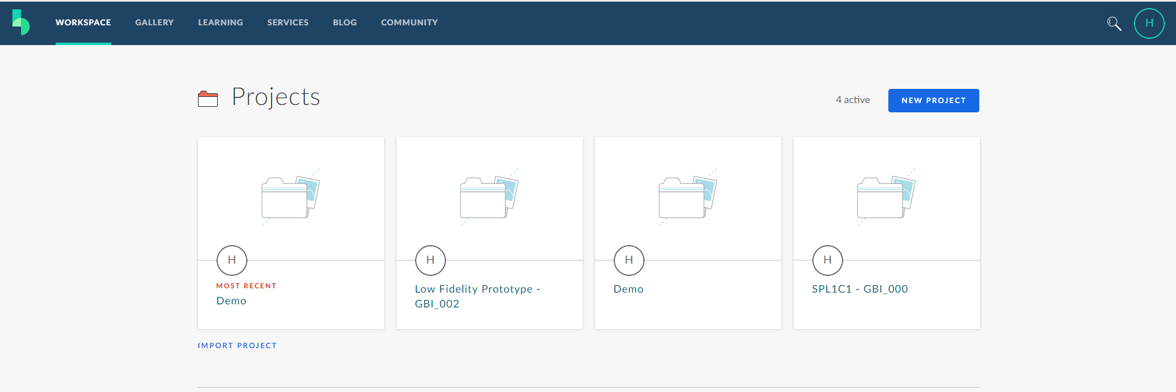

Select Gallery from the top menu. Enter Inventory in the search field. Select the Inventory Dashboard template.

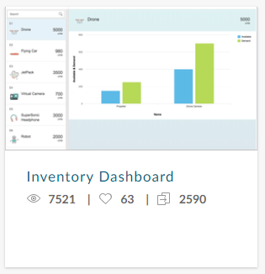

The next screen shows some details of the template.

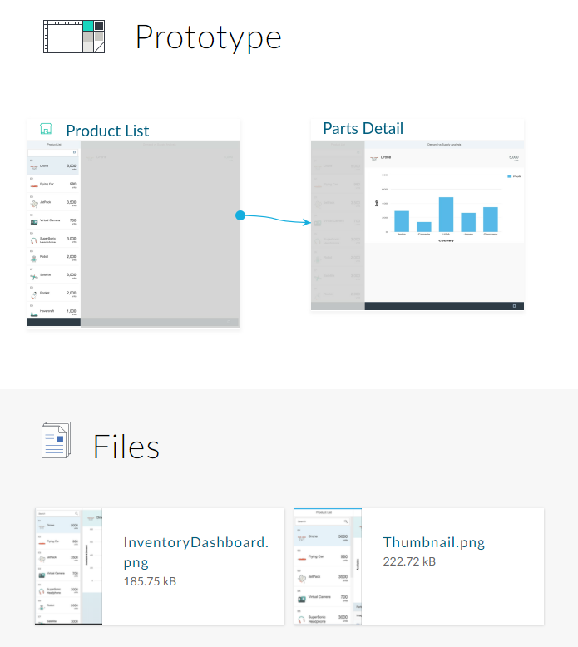

Click the Try It button to see the app in action.

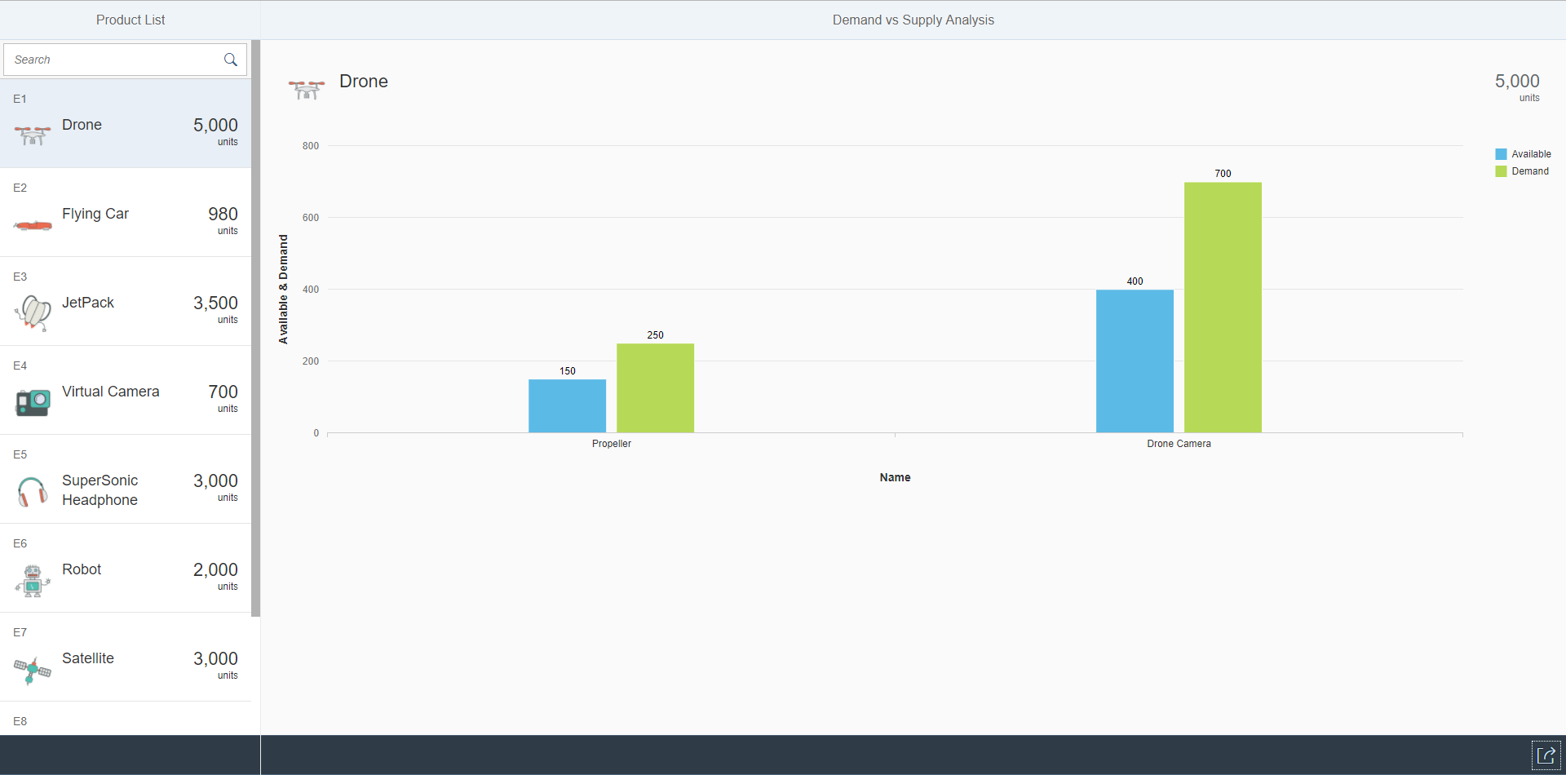

Click Clone to clone the template.

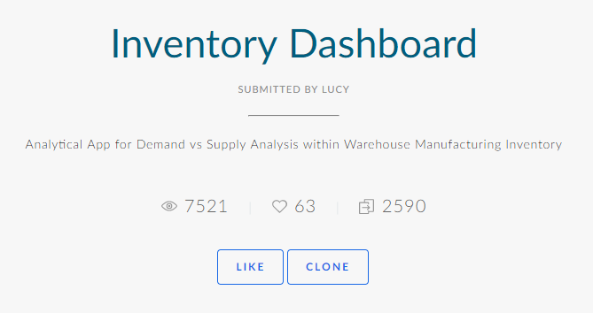

Then click Clone again.

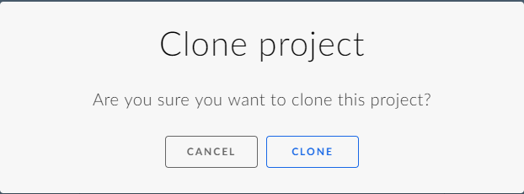

## Modify the Prototype

Click the Product List screen thumbnail to open it in the editor.

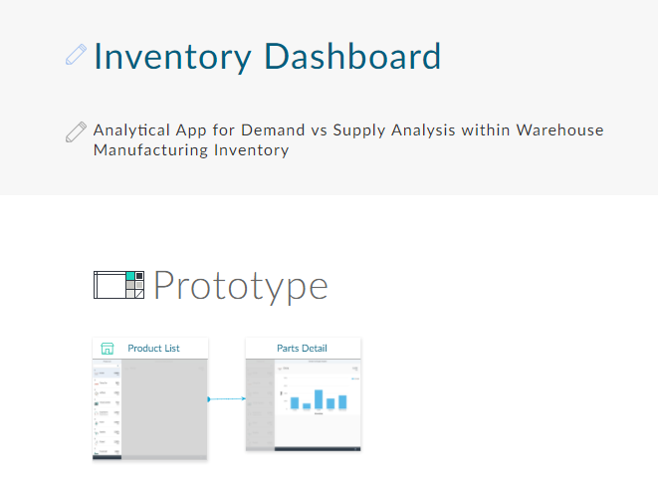

The editor allows you to add/delete or modify the controls in the app.

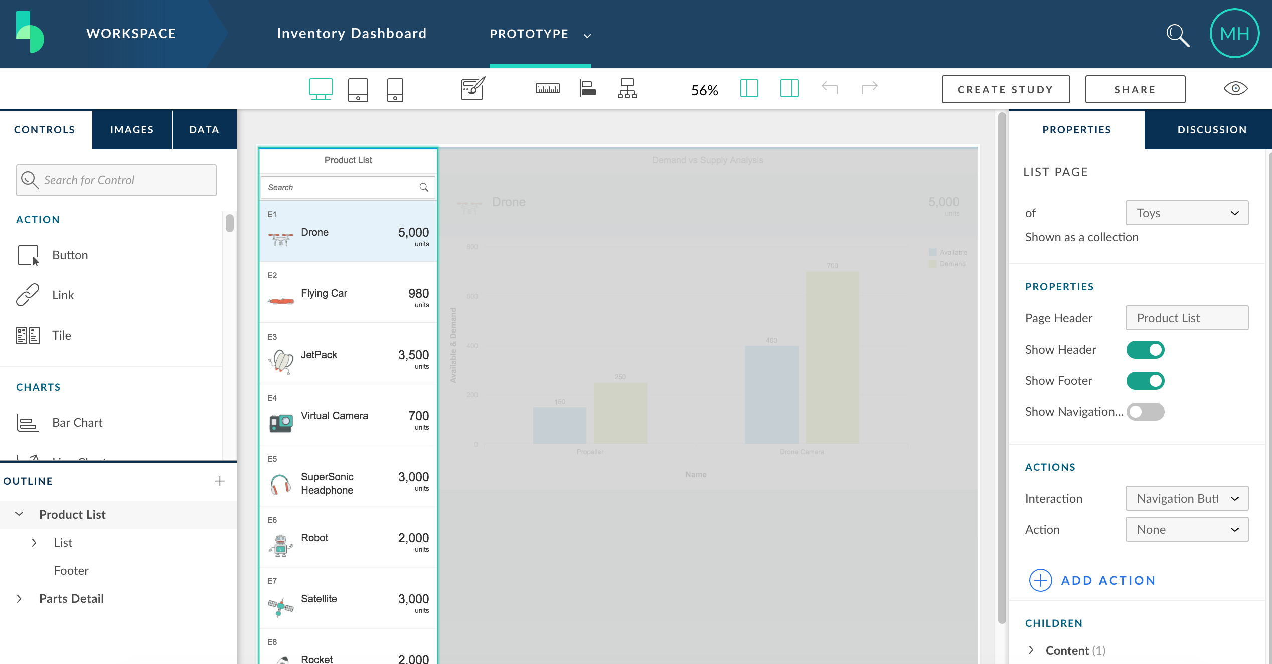

Click the grayed out area in the center of the screen to select it.

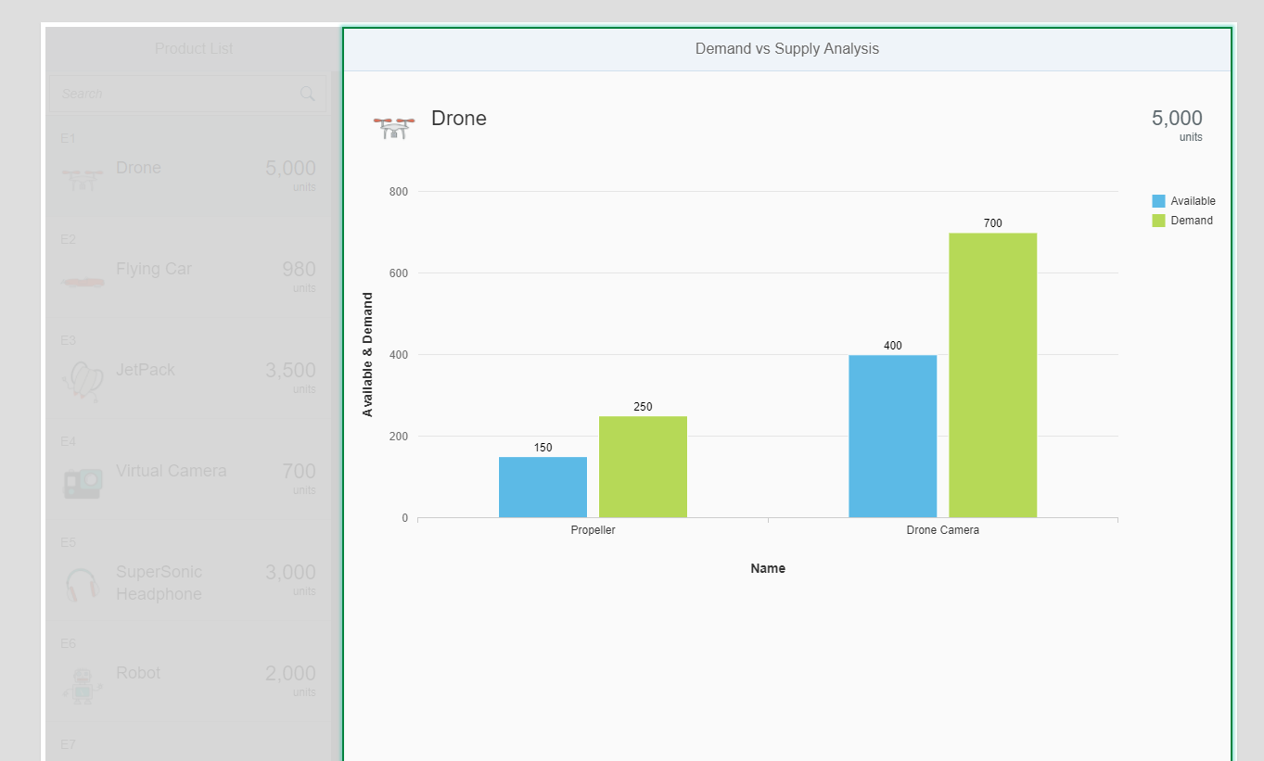

Enter table in the search field on the Controls tab on the left side of the screen.

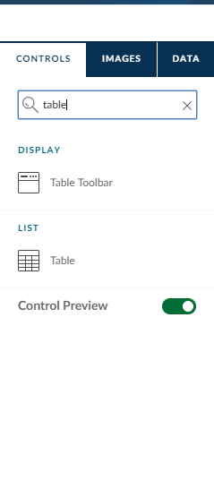

Drag the Table control to the space below the graph.

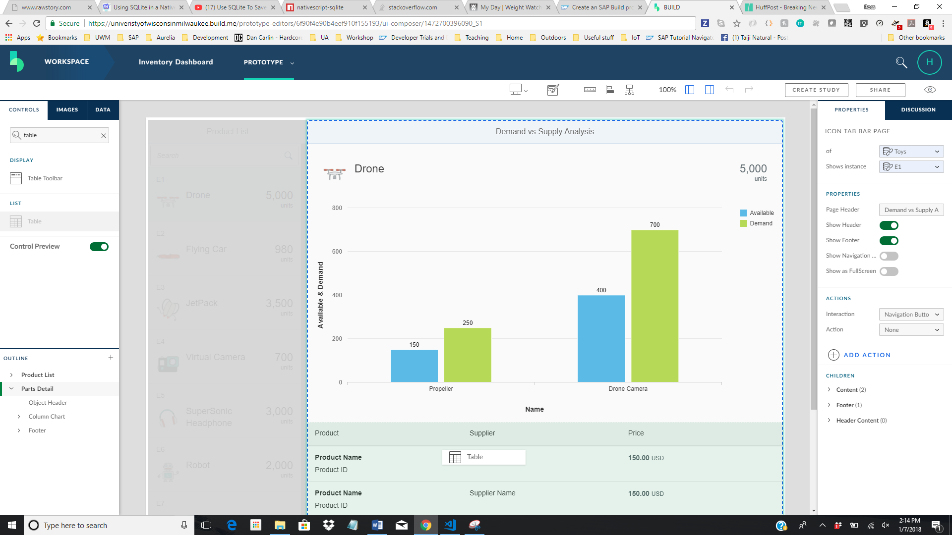

Click the Product column header to select the column. Next, right-click the column and select Add Column Left to add a new column.

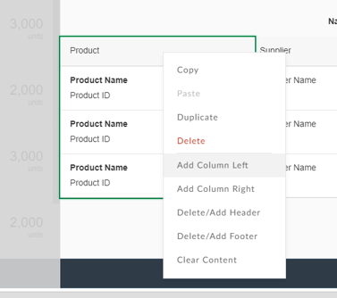

Add a second new column.

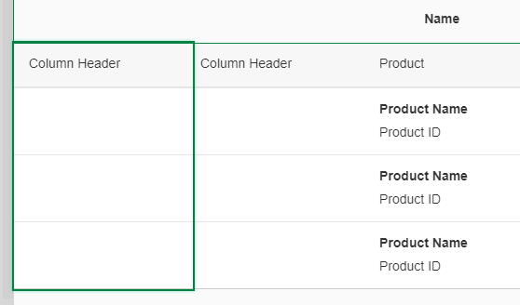

Double-click the column headers to change them as shown.

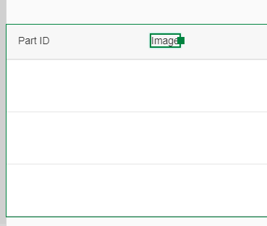

Search for the Label control.

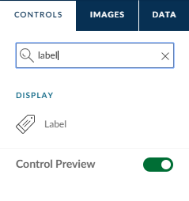

And drag it to the first column.

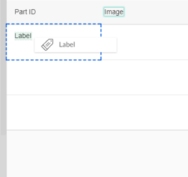

Now, add an image control to the second column.

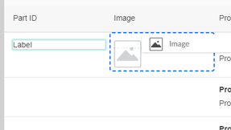

With the image control selected, modify the control properties on the right side of the editor as shown.

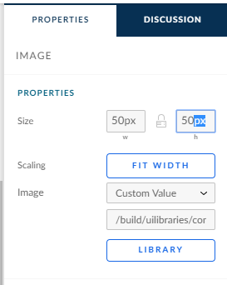

The template has been pre-populated with sample data. Select the Data tab on the left side of the editor.

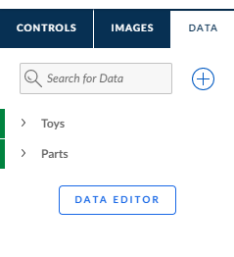

Drag the Parts entity onto the table.

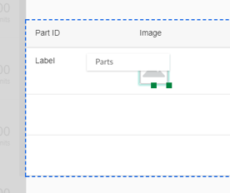

The property names that match the column headers will automatically map to the columns.

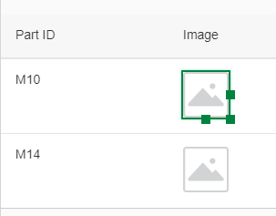

You can also manually map a property by dragging the property itself. Expand the Parts entity.

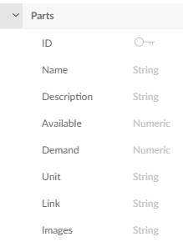

Drag the Images property onto the Image control.

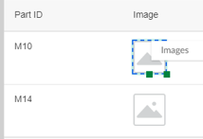

You can use the Data Editor button to view or edit the data.

## Preview the Prototype

Click the eye icon to preview the prototype.



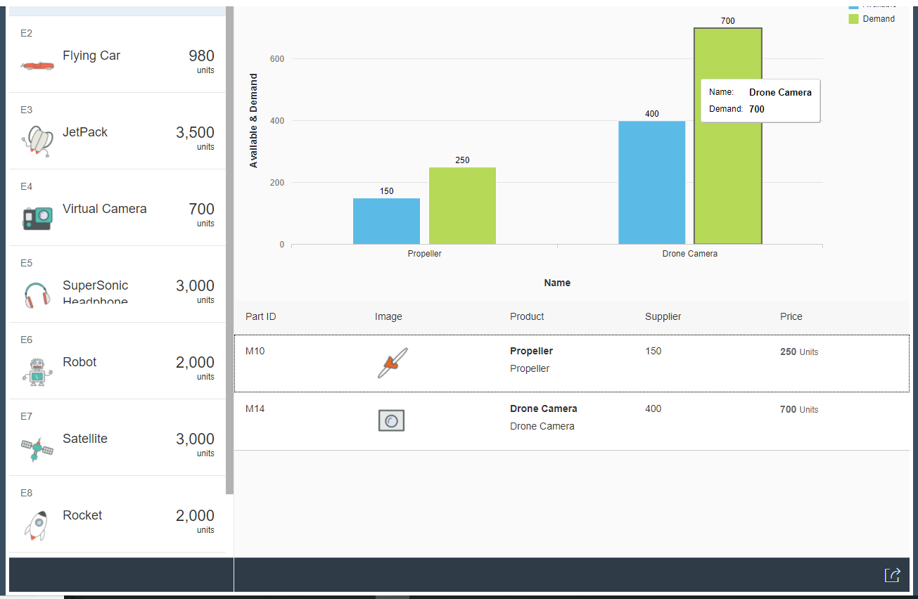

Use the icon on the top right to view the app in different device types.

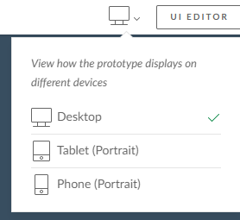

One of the powerful features of UI5 is responsiveness, the ability to adjust automatically to different screen sizes.

Click UI Editor to return to the editor.

You can change the device type and the theme using the icons on the top of the editor.



Click Share to create a URL you can share with others or to download an archive with the application.

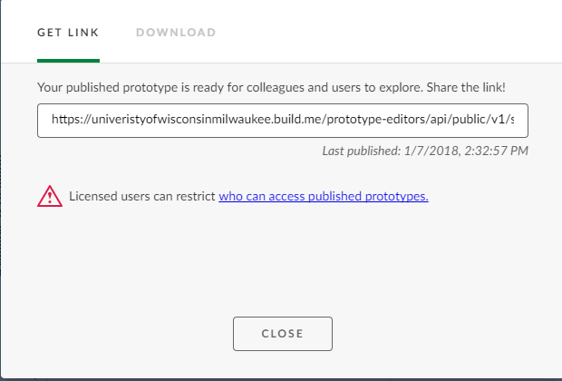

The zip archive that is downloaded can be imported into an IDE and developed into a finished app.

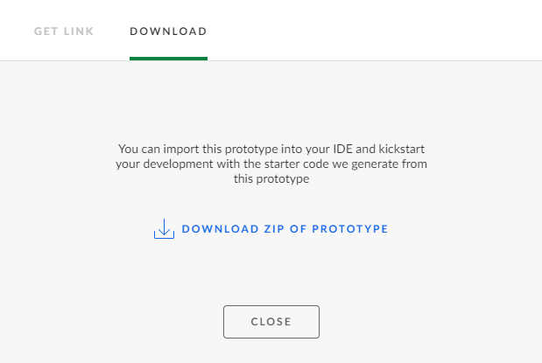

## Import the Prototype into the SAP Cloud Platform

Logon to the SAP Cloud Platform Cockpit and navigate to the Services page. Locate the Build Service.

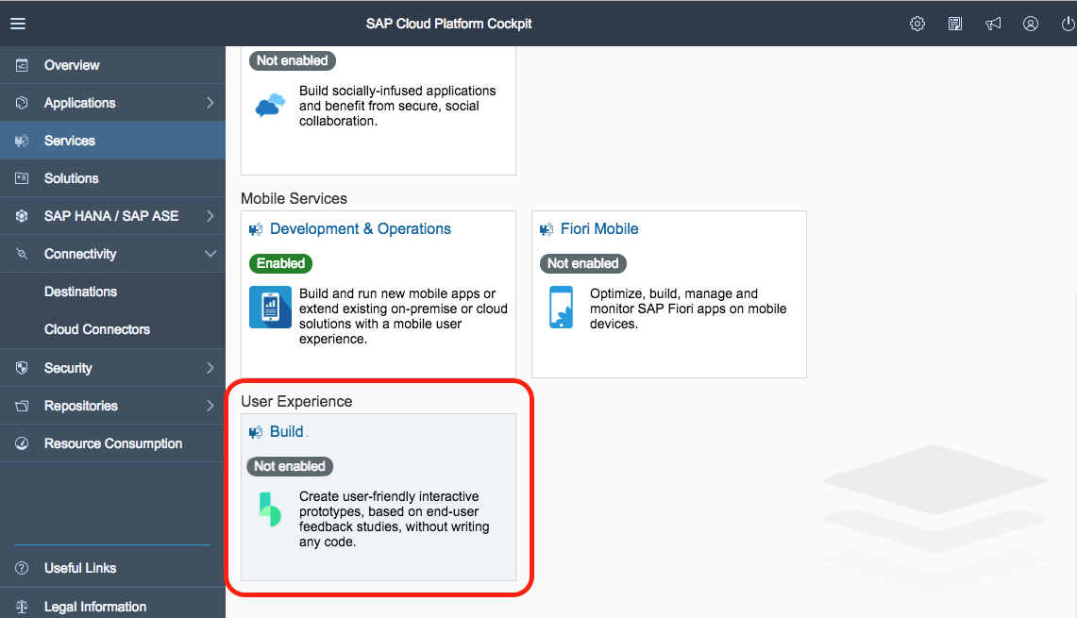

Click the tile and then click the Enable button.

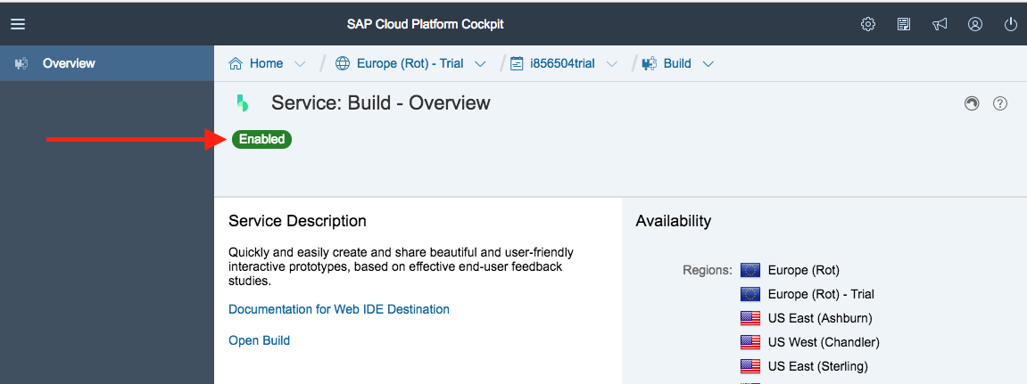

Next, navigate to the Destinations screen and use the Import Destination to import the four destinations files listed below



* [BUILD Production Destination](https://raw.githubusercontent.com/SAPDocuments/Tutorials/master/tutorials/build-import-webide/BUILD_Production)
* [SAPUI5 Destination](https://raw.githubusercontent.com/SAPDocuments/Tutorials/master/tutorials/build-import-webide/sapui5-private)
* [SAPUI5 Private Destination](https://raw.githubusercontent.com/SAPDocuments/Tutorials/master/tutorials/build-import-webide/sapui5-private-build)
* [SAP Web IDE Plugin](https://raw.githubusercontent.com/SAPDocuments/Tutorials/master/tutorials/build-import-webide/Web_IDE_PLUGIN)

Logon to the Web IDE and click the Gear icon on the left tool bar. Select Plugins and then select BUILD Destination in the dropdown list.

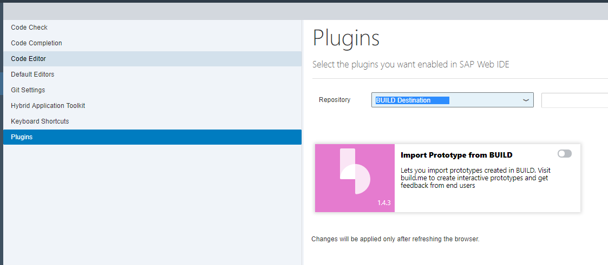

Click the switch to enable it then click Save.

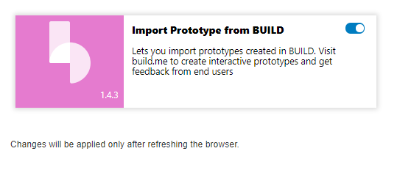

After the browser refreshes, click the Home icon then click the New Project from Template icon. Select the BUILD template.

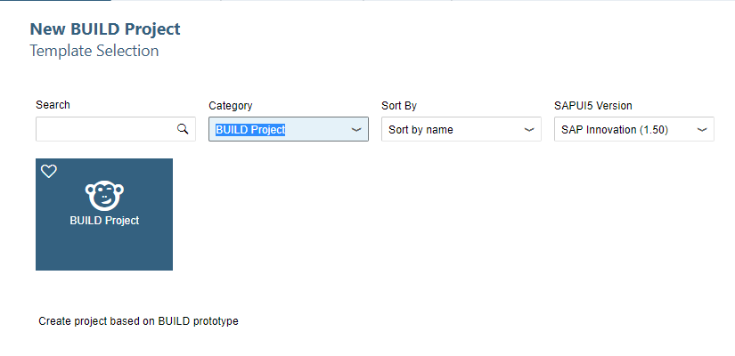

Give the project a name.

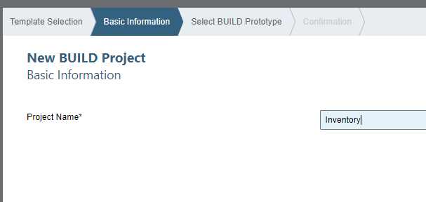

Logon with your BUILD credentials.

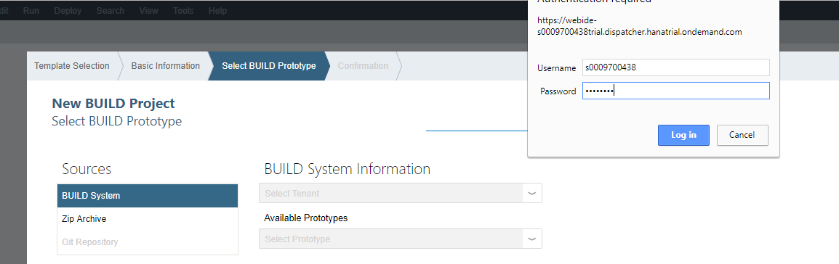

Enter standard in the top dropdown list (not like the image below) and then select your prototype in the Available Prototypes list. Click Finish.

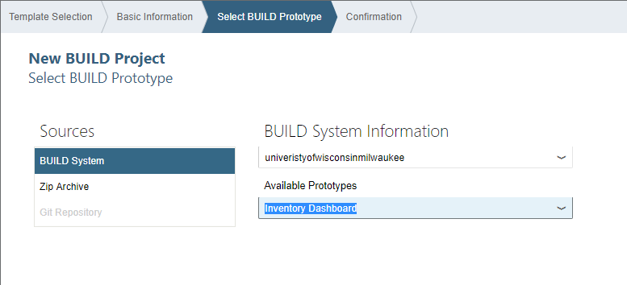

Select the project folder and click the run icon.

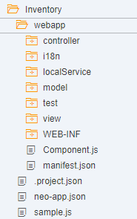

Select the testFLPServiceMockServer.html file for the test data and click OK.

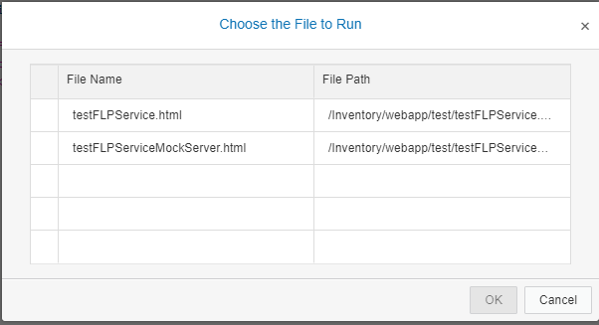

A Fiori launchpad opens. Click the tile for your app.

